**TEST DATA CREATION :**

**ADH Account :**

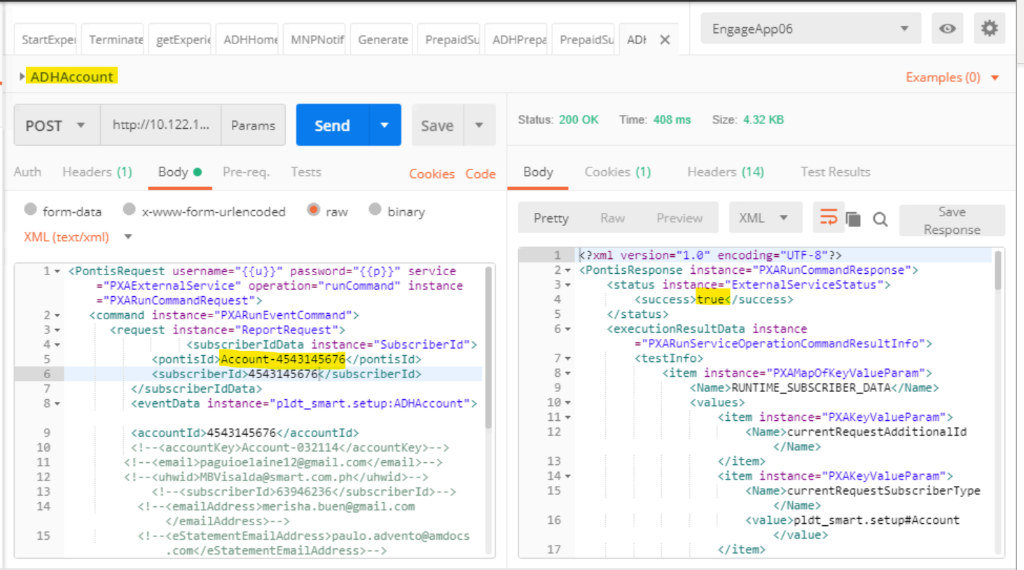

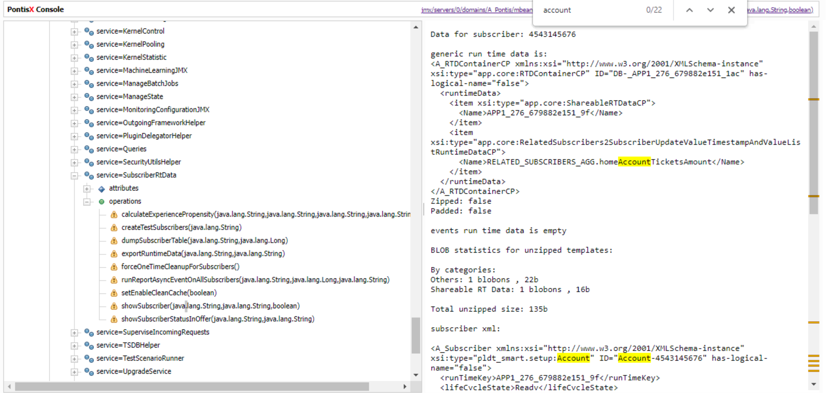

**TC : 1**

**Start Experience for Account :**

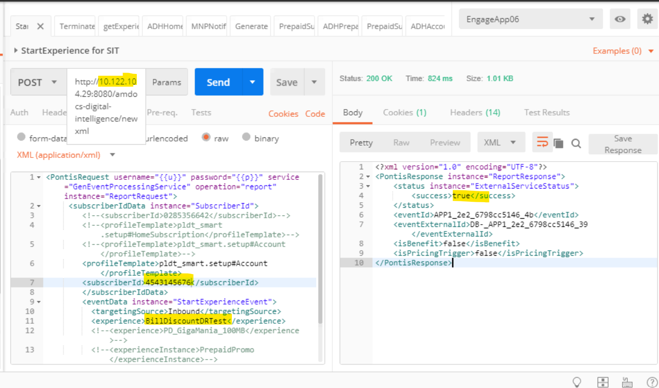

**01 GET EXPERIENCE FULL DETAILS :**

**Verify Subscribers enters into the camapaign successfully:**

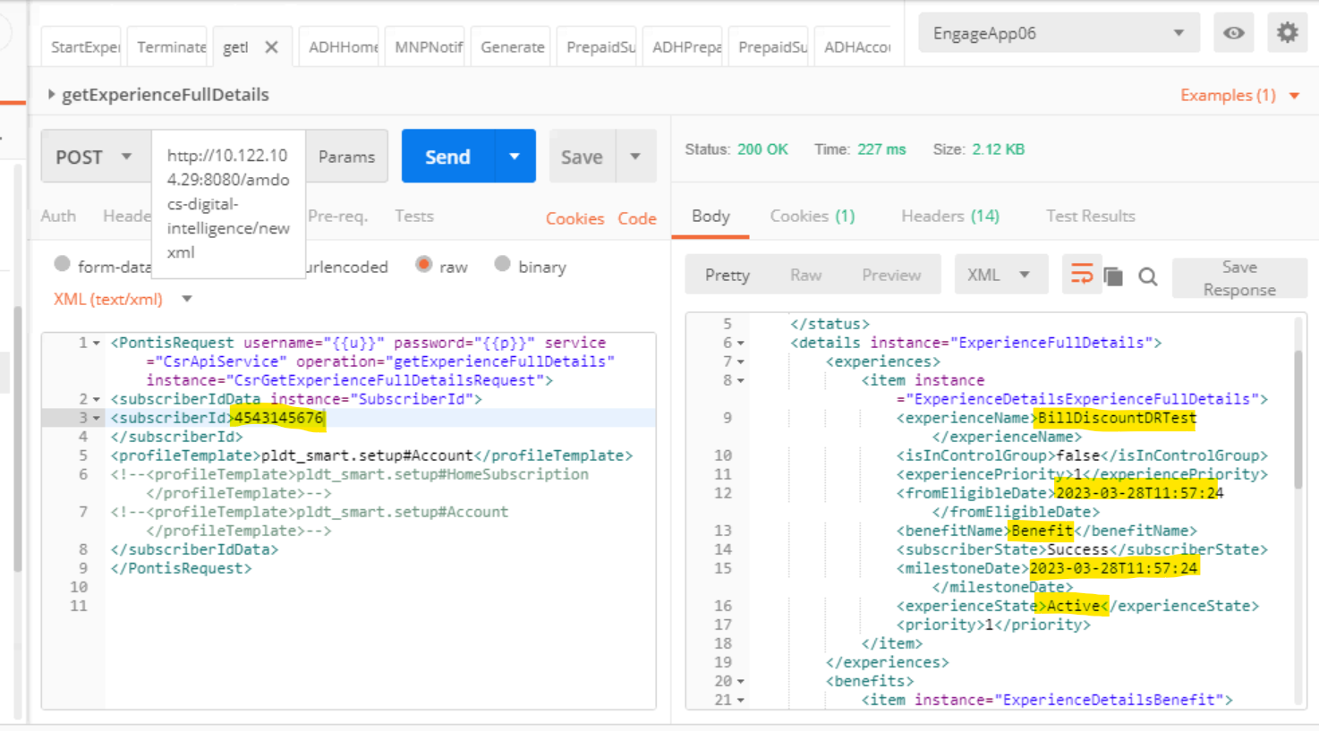

**Run the Job :**

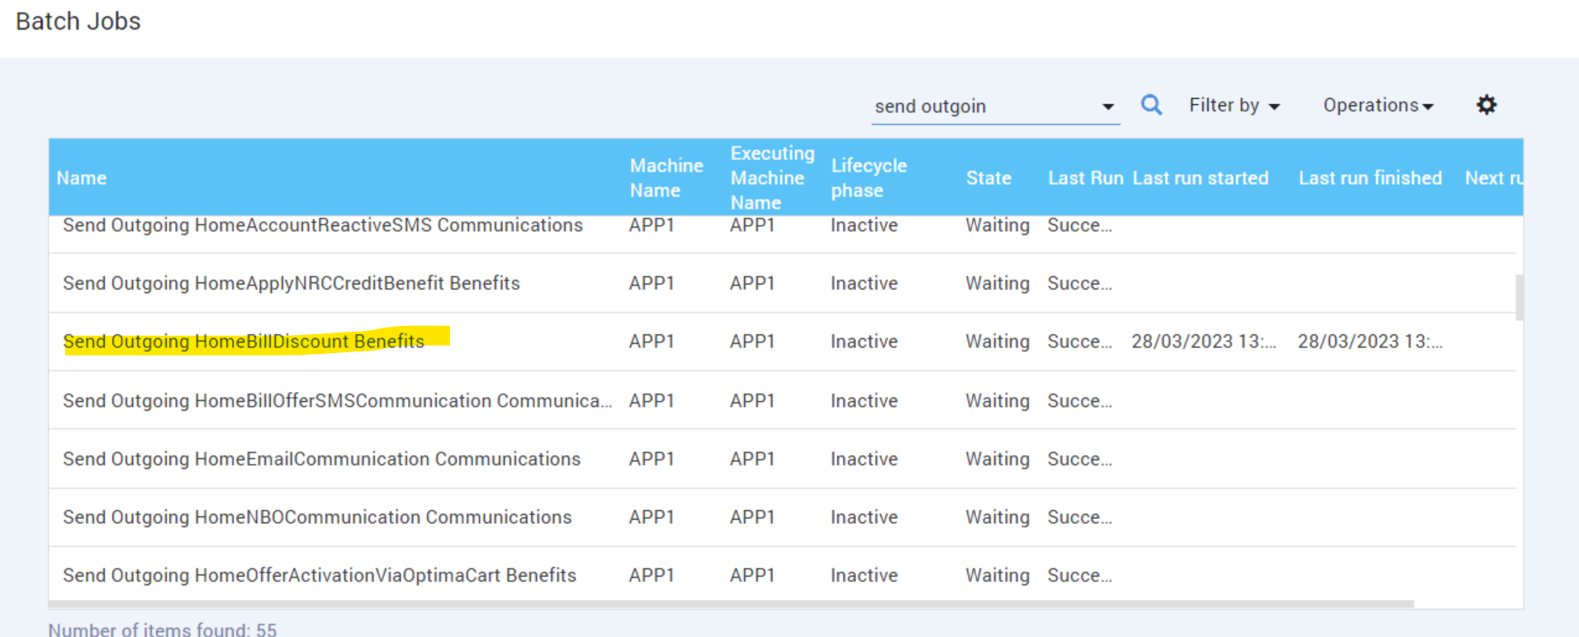

**02 .Verify Request file is generated :**

1.File Name Convention should be in the format of BILL_DISCOUNT_001_<TIMESTAMP>.txt

2.Verify whether file contains all the attributes

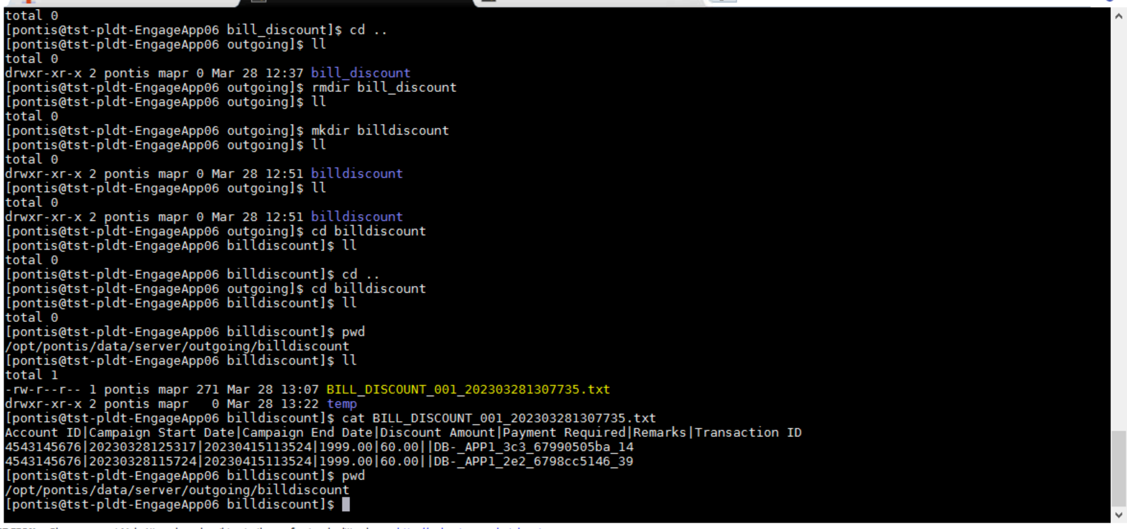

**Run FTP upload billdiscount Job**

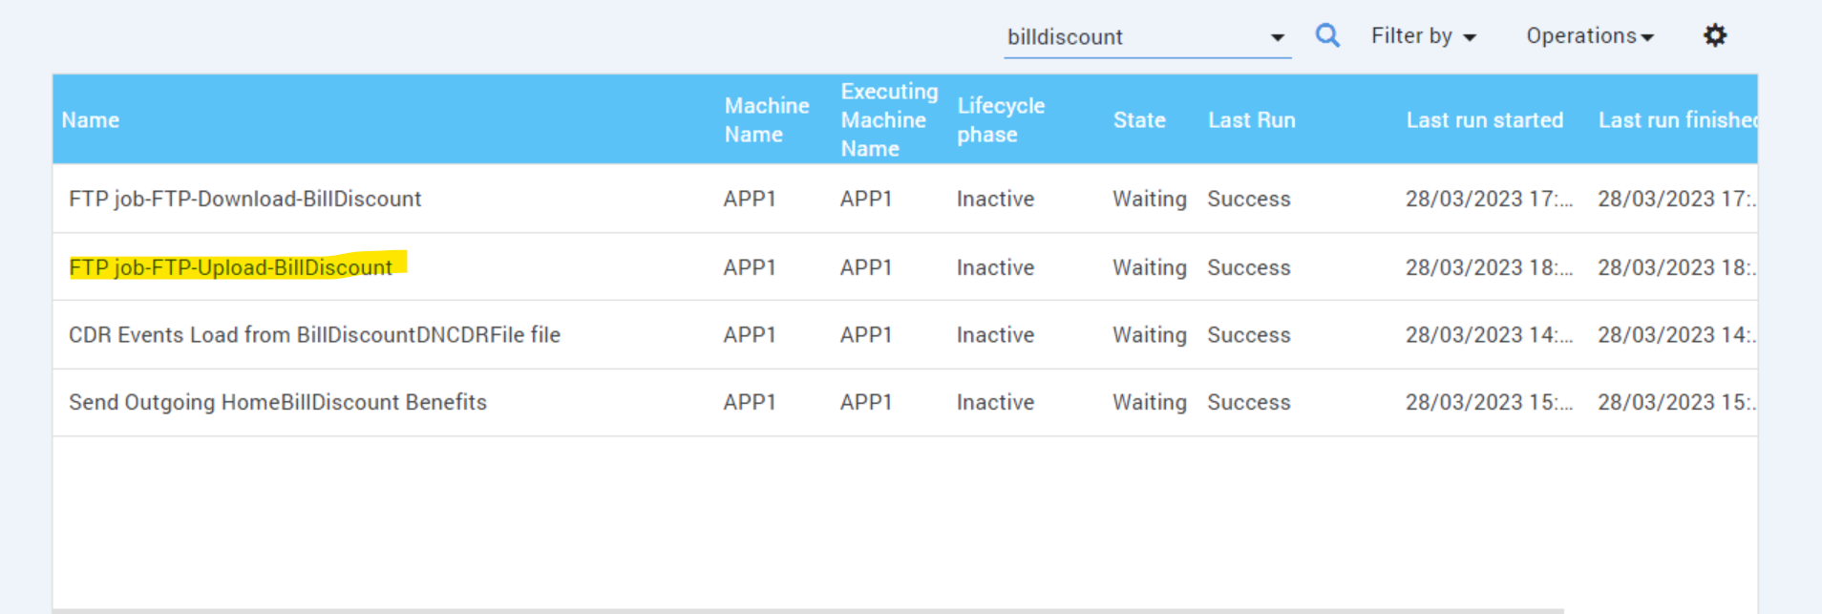

**Need to check adhapp05 : cd** /adh/fsuser/pldt/interfaces/SITAPP06/kenan/billdiscount/outgoing (request file)

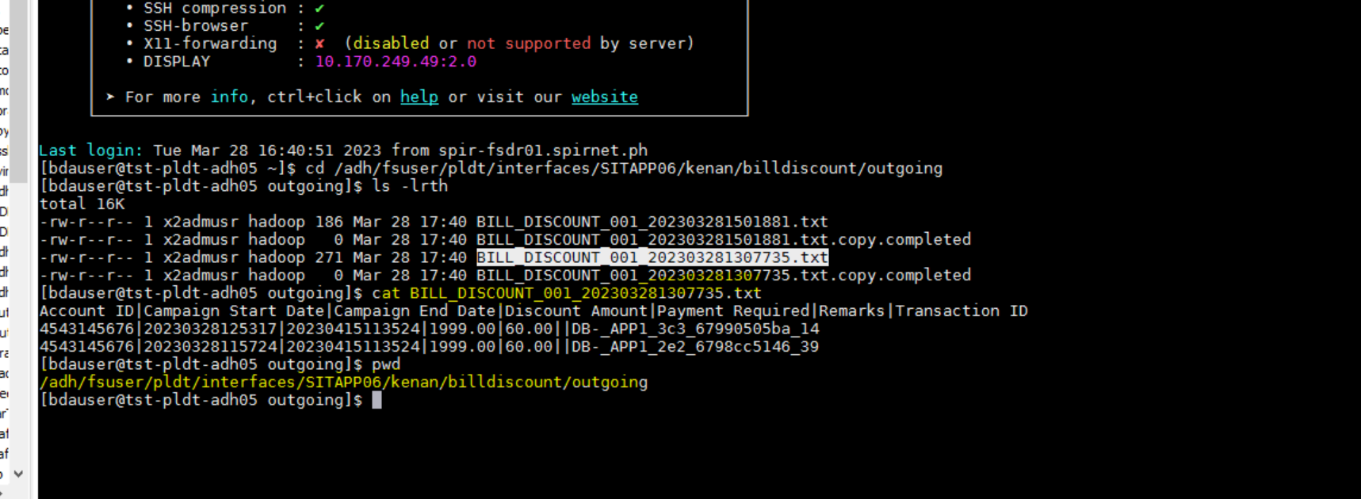

**Folder:**

**Now go to adh05 new target folder we need to create the file manually and run ftp download job now the file will be incoming and it will be processed.**

**Creation of response file manually:**

cd /adh/fsuser/pldt/interfaces/SITAPP06/kenan/billdiscount/incoming : **Response File**

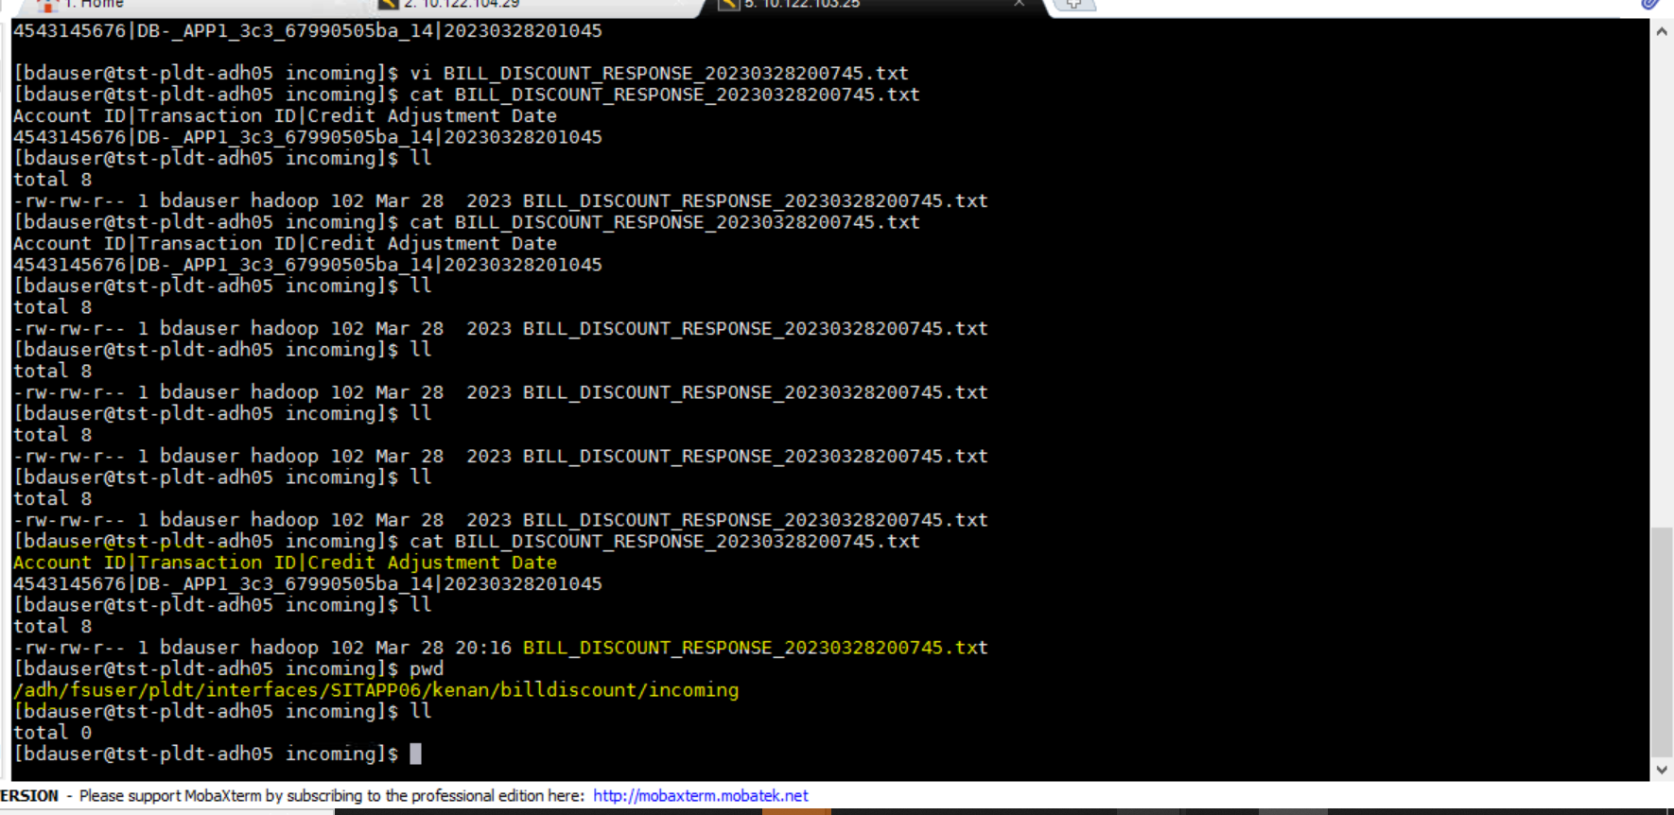

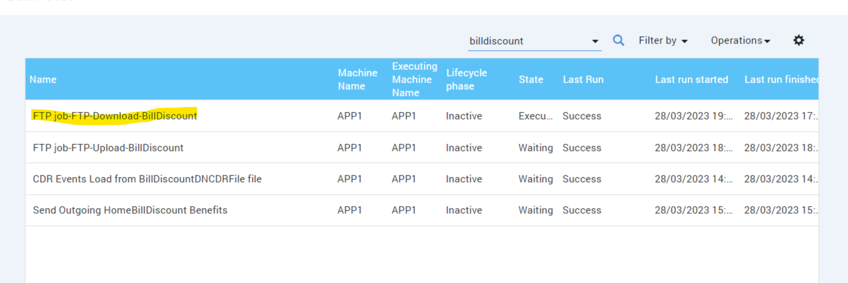

**File got transferred to SITAPP06:**

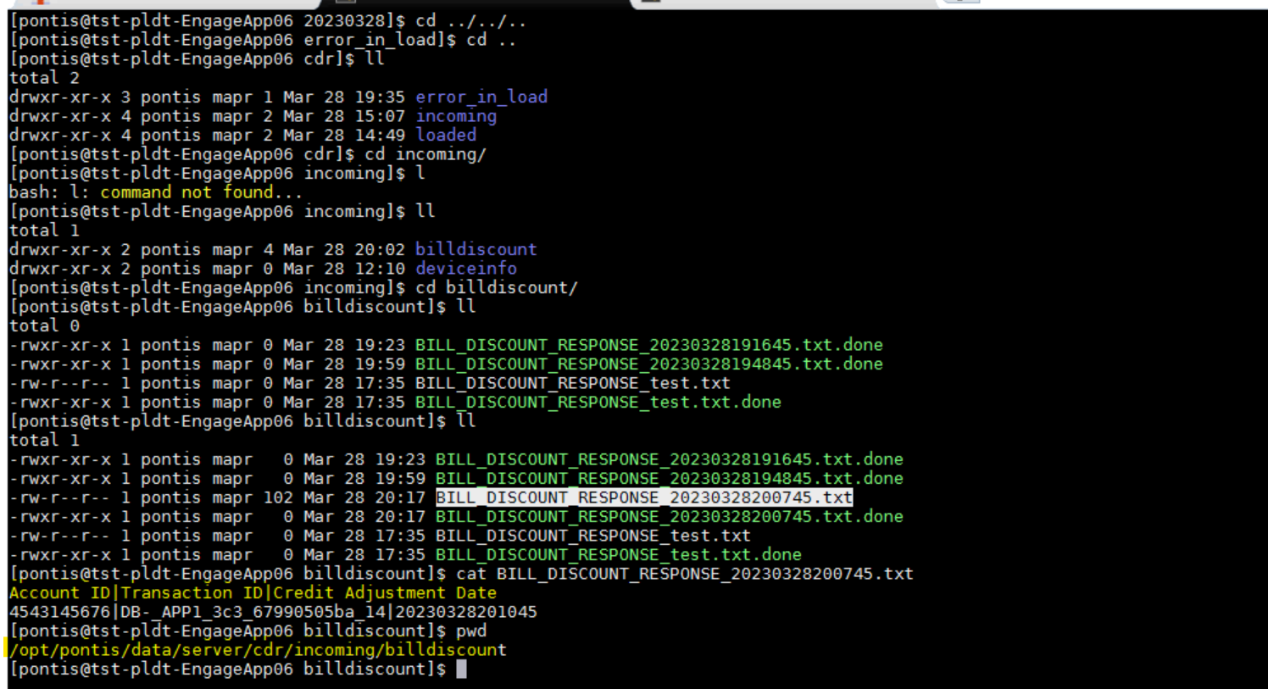

**04 : Trigger the "CDR Events Load from BillDiscountDNCDRFile file" Job**

1.Verify whether responce file process successfully

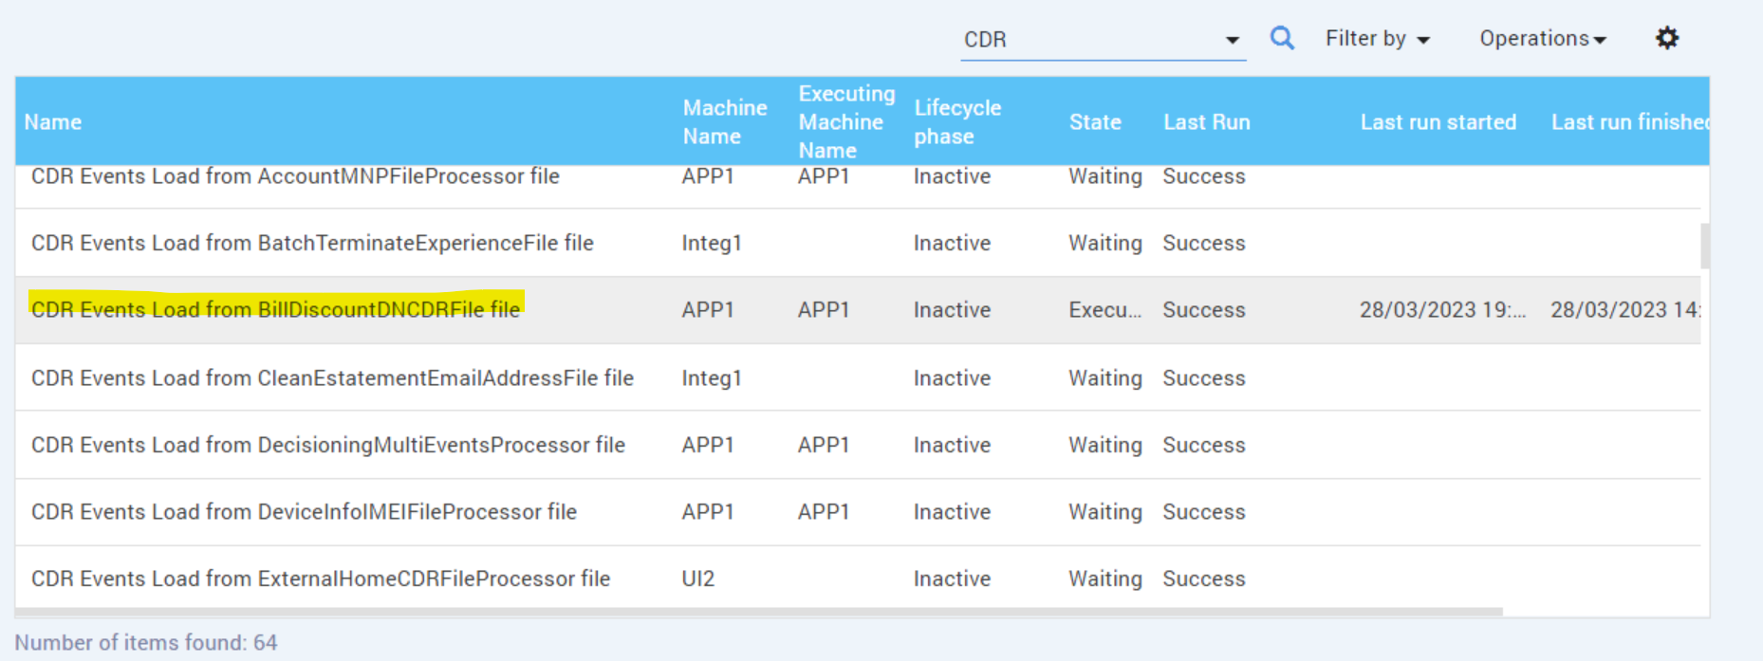

1.Verify whether responce file process successfully

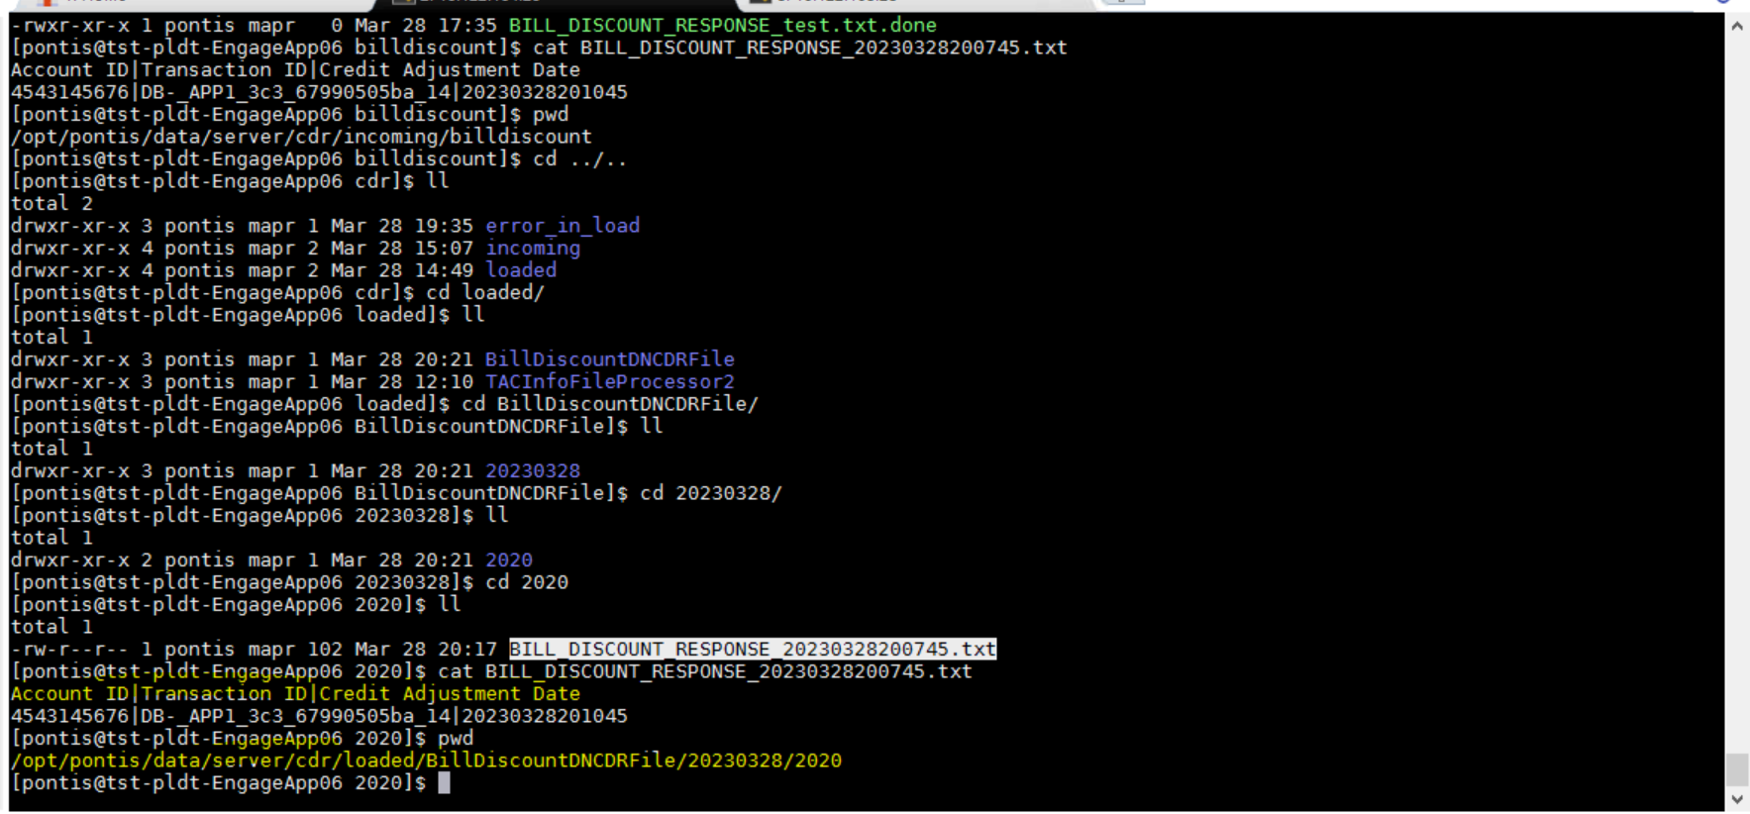

**Verify AccountBillDiscountSuccessEvent Event Generated successfully**

1.verify whether benefit is granted successfully

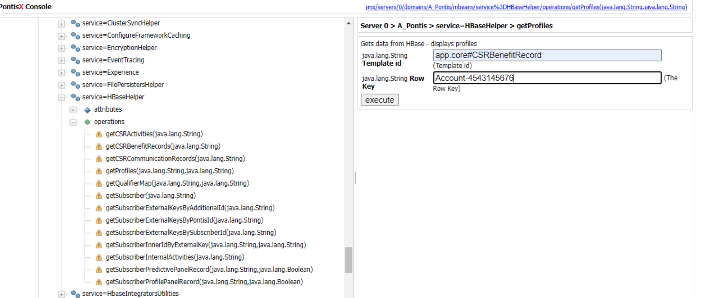

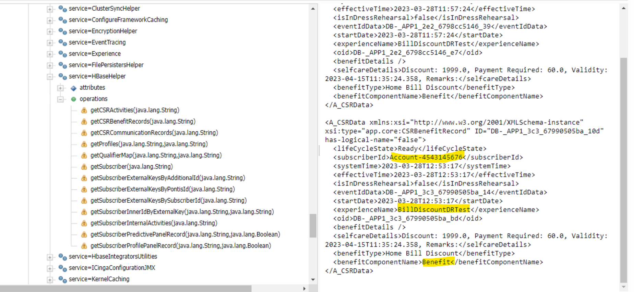

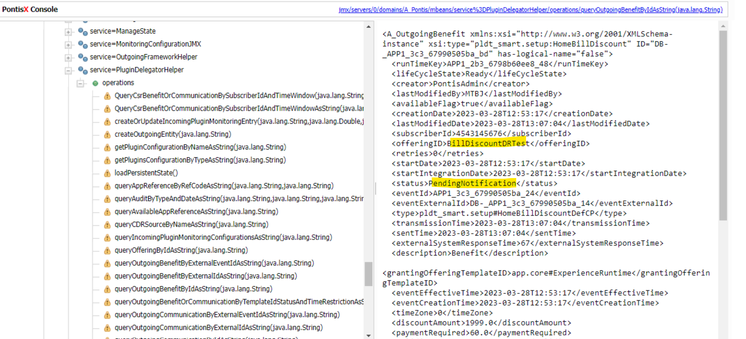

**Run AccountBillDiscountSuccessEvent :**

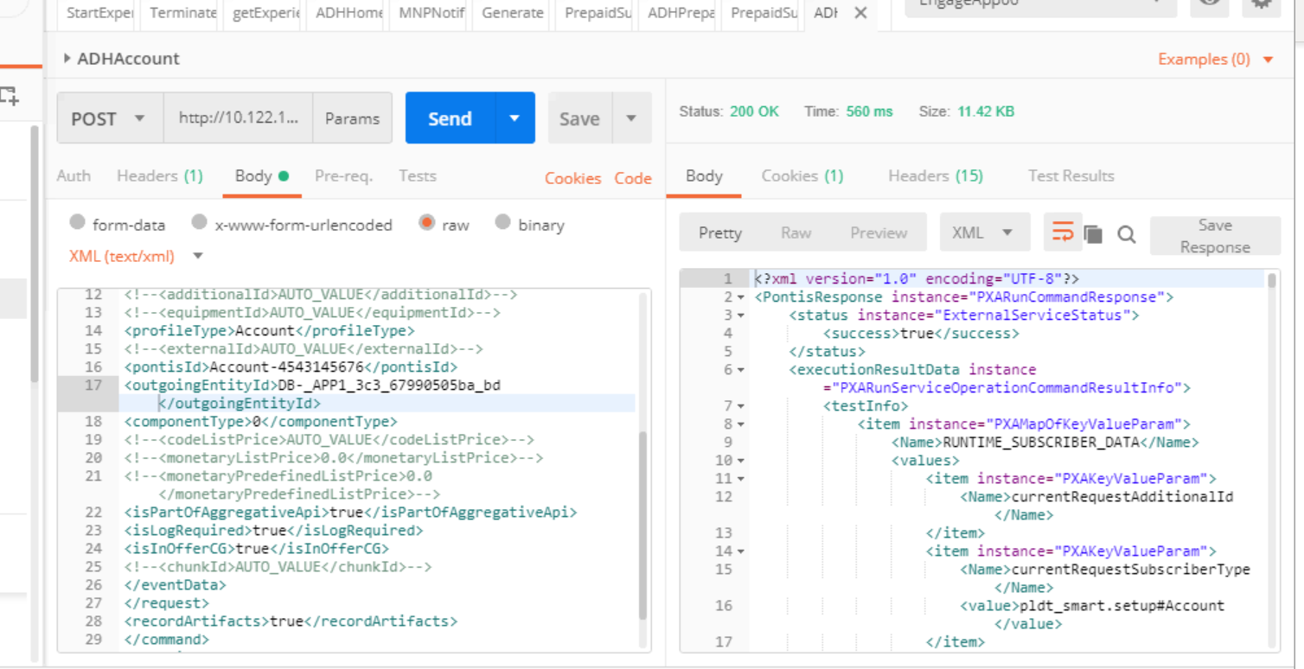

**Verify AccountBillDiscountSuccessEvent Event Generated successfully :**

1.verify whether benefit is granted successfully

